

SCHOOL *of* BUSINESS AND TECHNOLOGY

Department of Engineering and Aviation Sciences

**Oyster Activity Detection System**

**Shanice Nurse**

**Ashley Afueh**

Advisor: Dr. Zhang

October 28, 2020

Oyster Activity Detection System

By

Shanice Nurse & Ashley Afueh

Submitted to the Department of Engineering and Aviation Sciences in partial fulfillment of the requirements for the degree of Bachelor of Science in Engineering at the

UNIVERSITY OF MARYLAND EASTERN SHORE

Date

The author hereby grants the University of Maryland Eastern Shore permission to reproduce and distribute publicly, paper and or electronic copies of this document in whole or in parts.

Authors Shanice Nurse, Ashley Afueh

Signature

Date

Department of Engineering and Aviation Sciences

Certified by

**List of Contents**

**List of Contents 2**

**List of Figures 4**

**List of Tables 5**

**Abstract 6**

**1.** **Introduction 7**

**1.1** **Backgound/Motivation 7**

**1.2** **Objective 7**

**1.3** **Design Requirements 7**

**1.4** **Design Constraints 7**

**1.5** **Design Methods 7**

**2.** **Project Description 9**

**2.1** **System Description 9**

**2.2** **System Diagram 9**

**2.3** **System Functions 9**

**3.** **Implementation Plan 11**

**3.1** **Tasks 11**

**3.2** **Team Organization 12**

3.2.1. Responsibility of Team Member 1. 12

3.2.2. Responsibility of Team Member 2. 12

**3.3** **Timeline/Milestones/Delivery Plan 12**

**4.** **Implementation 13**

**4.1** **Implementation of Task 1. 13**

4.1.1. Implementation of Subtask 1.1 13

**4.2** **Implementation of Task 1. 13**

**5.** **Conclusion (Discussion and Future Plans) 14**

**Acknowledgment 15**

**Appendix 16**

**A.** **Component Specs 16**

1. Specs of Arduino Due 16

2. Specs of Raspberry Pi 16

**B.** **Source Code. 16**

1. Source Code of Graphic User Interface 16

2. Source Code of Robotic Arm 16

**REFERENCES 17**

**List of Figures**

Figure. 1. Mussel Active Filtering (A), Voltage Output (B), and Mussel Resting (C). 6

Figure. 2. Design Methods. 7

**List of Tables**

Table 1. Project Timeline and Delivery Plan 10

**Abstract**

By the end of the project, summarize the project into short text and put here (can be waived for Senior Design I). The abstract needs to be more than half pag

Due to oyster cultivation oysters are able to naturally grow when in a farmed environment when the temperature and sanity of the water are controlled. In order to induce growth, and rate of maturation which could take several years. In this paper, we apply a convolutional neural network (CNN) to the task of detecting oysters and recognizing the activity of each individual oyster. Because there is a wide diversity of sea creatures with different features, image recognition of sea creatures is generally very difficult. However, deep learning has been shown recently to be a very powerful image recognition technique to monitor different patterns and behaviors. The convolutional neural network is designed to detect the oyster’s activity; the oysters are in two states, either active or rest through parameter optimization. We constructed a dataset of numerous images of individual oysters both active and resting in a publicly accessible cloud storage system and used it to evaluate recognition performance. CNN showed significantly higher accuracy than did traditional support-vector-machine-based methods with handcrafted features. In addition, we found that convolution kernels show that color dominates the feature extraction process. For oyster activity mage detection, CNN also showed significantly higher accuracy than a conventional method did.

1. **Introduction**

## 1.1 Background/Motivation

Oysters provide a positive environment for the coastal and estuarine waters. Shellfish cultivating can give communities an assortment of environmental benefits, whose worth can be quantified. oysters have the ability to clean the water which they’ve grown in by filter feeding. By this way of feeding, oysters filter phytoplankton, microorganisms, and detritus. By filtration, oysters improve water quality by diminishing sediment loads and turbidity and expelling abundance supplements from inshore coastal waters. Clear water quality permits more daylight to infiltrate, which helps in the development of significant seagrasses and expands oxygen.

The capability of remotely monitoring the behavior of oysters and their relationship with their habitat has restructured how ecologists conduct research. Shellfish cultivating can give nearby communities an assortment of environmental benefits, whose worth can be quantified. Freshwater mussels (Unionoida) are target species in aquatic conservation and belong to one of the fastest diminishing taxa globally (Bogan, 1993; Geist, 2010, 2015). Most recently, there has been a critical effort to put resources into improving the conception of the reasons for the decrease of Unionoida. Biologists have urged the discovery of a solution to observe the behavior, physiology, and ecological conditions experienced by creatures as they progress and communicate with their habitat. On account of the mechanical advances made in the course of the most recent 40 years, a wide range of approaches have been created to precisely comprehend the lives of creatures that go overlooked by the observation of an ecologist. Comprehensively, the strategies used to monitor oysters are directly related to the "biotelemetry", which can be characterized as the remote detection of physiological, or behavioral activity information. It is effective to include biotelemetry into the study of oysters in order to have a precise understanding of its preservation to the ecosystem. The standard amount of biotelemetry incorporated in research, differs enormously, from the utilization of data recorded, to transmitters that send data to either land-based receivers, or to a satellite circumnavigating the earth. For this reason, researchers and different articles suggest it useful to attach sensors to the mussels’ shell for ecological investigations and preservation ventures.

Various research projects range from, but are not limited to, mark-recapture studies to translocation and restocking programs, and mussel behavior research (Smith, Villella & Lemarié, 2003; Villella, Smith & Lemarié, 2004; Kurth *et al.*, 2007; Wilson *et al.*, 2011; Hartmann *et al.*, 2015). For instance, the controlled release of captive-reared freshwater pearl mussels (*Margaritifera margaritifera*) requires effective tools to monitor the success of such conservation projects (Gum, Lange & Geist, 2011). Adjoining sensors to a mussel may bring about strain for the mussel and increase endangerment to their vulnerability to harmful mixes from the glue. To connect an item includes the expulsion of the mussel from its condition, cleaning and drying the shell, applying the paste, squeezing the remote article against the shell and, for some paste', the procedure additionally includes keeping the mussel out of the water until the paste is dry. Currently, there are experimental studies of filtration-behavior and biological rhythm for freshwater mussels. Biologists perform their research by attaching objects to bivalve shells for conservation projects, mark-recapture studies, and behavioral analysis. The “marking” process is performed by using a magnet and a rubber-coated Hall sensor glued with cyanoacrylate adhesive attached to a mussel shell known as the “Anodontia Anatina.” These attachments were built to last for nine months after attachment. This system was designed for a filtration-behavior experiment, which identified a circadian rhythm. This experiment was performed by placing twenty-six mussels that were randomly selected were placed into two different closed recirculating aquarium systems. After allowing the mussels to adapt to their laboratory habitat for about 12 days, a Honeywell SS495A linear position Hall sensor (Honeywell, USA) and magnet were then attached for monitoring behavior. Additionally, this system allowed ecologists to observe the water quality parameters, dissolved oxygen (DO), pH and EC daily. Figure 1 depicts the measurement of a mussel’s filtration behavior using the change in proximity of a magnet (in right valve) to a Hall sensor (on left valve). In Figure 1, photograph B depicts a graph showing a measurement of the voltage output transduced by the Hall sensor when the mussel is active and resting.

Figure 1.

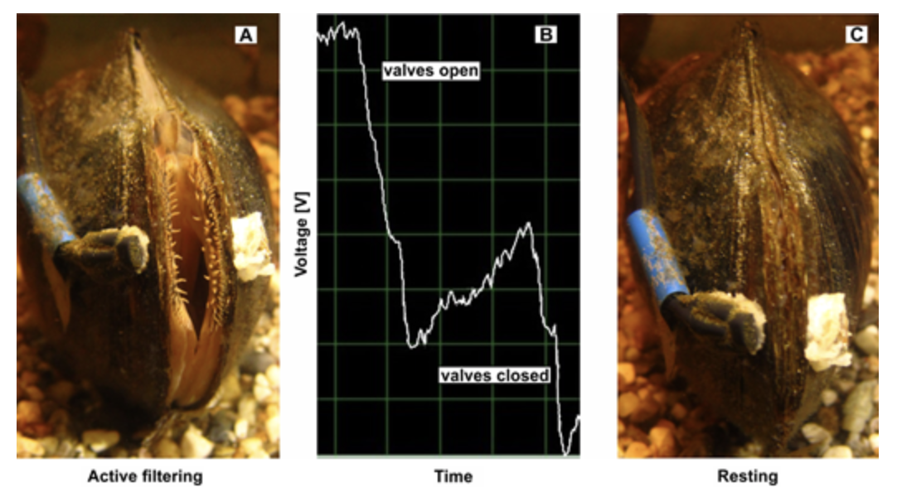

1. Mussel Active Filtering (A), Voltage Output(B), Mussel Resting(C).

This project is intended to assist in research for the Food & Science Department at the University of Maryland Eastern Shore. By developing a oyster Activity Detection System, a dataset from the activity of the oysters will be derived from the activity observed without putting addition strain on the oysters. This would be extremely beneficial to ecologist and researchers as they can remotely monitor precise data from their experiments. The dataset will be the basis for the development, evaluation, and use of the neural network developed. During this project, there will be models developed for photograph classification, and object detection to further investigate the activity of oysters. By creating this development, the department will have a better insight of the oysters’ behavioral activity with its environment. The Deep learning Convolutional Neural Network will be trained with an image classification model to observe each oyster individually. This neural network is intended to monitor the oysters’ amount of interaction, length of interaction, growth, and its overall adaptivity to its surroundings. This deep learning model will have the ability to integrate the feature extraction and classification process into a whole to record when the oyster is most comfortable.

The purpose of this project is to develop a SMART system that will precisely monitor the activity and interaction of oysters without the tedious strain imposed on their shell. By using deep learning approach to monitor the oyster’s activity the data will be recorded with increased accuracy. As previously stated, there methods on the market that will accomplish similar tasks as our system. However, the methods do not offer the precision and comfortability our system can guarantee.

## Objective

The objective of this project is to design a program applying deep learning neural networks to monitor oyster activity level and create a website that displays data from the oyster activity level.

## Design Requirements

1. Design a program using a deep learning neural network to monitor activity levels for each oyster individually.

1. Design a website for data analysis of oyster activity.

## Design Constraints

1. $200 budget
2. Light system is required for 24-hour monitoring

## Design Method

The initial task for designing a neural network which is intended to classify images of active and/or resting oysters is the laboratory setup. The laboratory setup which consist of the Pi camera utilized to take training and testing images is important for the image processing aspect in the Convolutional Neural Network design implementation. A system diagram for the design method can be seen in figure 2 displays the design method in order to completion. After the design of the deep learning neural network is completed the program will need to be tested and evaluated for further precision and accuracy determination. Finally, the program will need to be finalized. The results derived from the neural network will be displayed on a website which can be accessed by researchers. The website will include live oyster images, and logged activity from individual clams.

Figure 2. Design Method.

## Standards

List in this section all (industry) standards the project complied with.

* + - 1. Biodiversity – ASC certified bivalve farms minimize impacts on the local ecosystem in a number of ways, such as ensuring that farms are not sited in areas with key biological or ecological functions. Farms must implement environmental management plans to ensure that they are not adversely affecting the ecological integrity of the area in which they are located. No harm to threatened or endangered species or their habitats is allowed.
      2. Pollution - ASC certified bivalve farms are required to manage the organic deposits on the sediment beneath the farm in a responsible manner. Sulphide levels in the sediment need to be measured at regular intervals and remain within set limits.
      3. Diseases - ASC certified bivalve farms must adhere to rigorous requirements to minimize disease outbreaks. Certified farms are not allowed to use harmful pesticides. If chemicals are used, only those that do not harm the marine environment are permitted. Farms must also ensure that actions to prevent diseases
      4. Wild seed collection - ASC certified bivalve farms that use wild seed must procure the seed from well-regulated natural resources.

1. **Project Description**

## System Description

This system intended to remotely monitor activity is controlled by a Deep Learning Convolutional Neural Network. For the project, the neural network is trained to identify various activities. A dataset will need to be prioritized with photographs of active oysters and resting oysters provided as a subset of photographs from a larger dataset. Using Keras the photos will be loaded to pre-process into standard directories. Python will then be used to create directories and subdirectories for both the “train” and “test” directories. After testing the dataset, a baseline Convolutional Neural Network will need to be developed. Different convolutional layers within the baseline model will be tested for accuracy. About three different VGG-based architecture models will be implemented to improve the performance by increasing the model capacity. This technique will alter the performance by allowing the model to learn features that will maximize the training dataset. After the process of model improvements, a final model configuration is selected and adopted. A final model normally includes all available data; the combination of train and test datasets. Through a web application, researchers will be able to view recorded datasets.

## System Diagram (or Flow Chart)

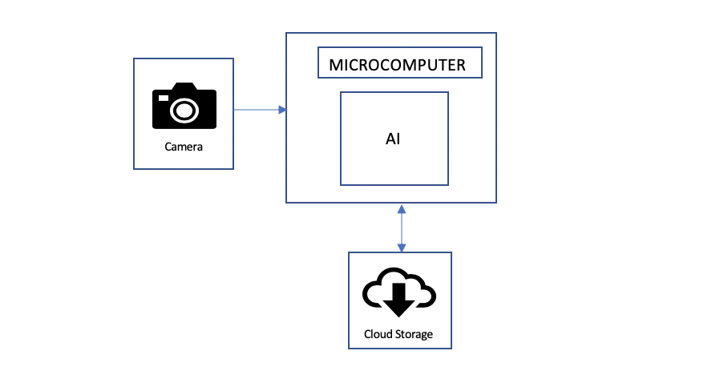

1. System Flow Chart

## System Functions

This system uses a camera which will monitor the oyster’s various activity; either resting or active. This information is then communicated to the Raspberry Pi. In the microcomputer, there is a system design which utilizes Artificial Intelligence and a Convolution Neural Network to process the data extracted from the images recorded. The data is then transmitted to a local network for visual recordings.

1. **Implementation Plan**

## - Tasks

All tasks are defined as the following:

* Task 1: Design software for practice image identification
  + Subtask 1.1: Load Data
  + Subtask 1.2: Generate Dataset
  + Subtask 1.3: Create Model
  + Subtask 1.4: Save/Load Model
  + Subtask 1.5: Save/Load Model (again)
* Task 2: Lab Setup
* Subtask 2.1: Mound Cameras to tank
* Subtask 2.2: Setup Raspberry pi for experiment
* Subtask 2.3: Setup any more other configurations
* Task 3: Design software for oyster identification
* Subtask 3.1: Photo dataset preparation
* Subtask 3.2: Develop a baseline CNN (convolutional neural network) model
* Subtask 3.3: Improvement on CNN model
* Subtask 3.4: Develop Transfer learning
* Subtask 3.5: Finalize CNN model

* Task 4: Design software for oyster activity level
* Subtask 4.1: Photo dataset preparation
* Subtask 4.2: Develop a baseline CNN (convolutional neural network) model
* Subtask 4.3: Improvement on CNN model
* Subtask 4.4: Develop Transfer learning
* Subtask 4.5: Finalize CNN model
* Task 5: Data Organization for Database
* Subtask 5.1: Sort Data Files
* Subtask 5.2: Writing Data to a file
* Subtask 5.3: Modeling Data for Database
* Subtask 5.4: Generate code to put obtained data to website
* Task 6: Generate Website Database
* Subtask 6.1: Organize layout for website
* Subtask 6.2: Upload data for general oyster activity and activity level
* Subtask 6.3: Upload data for individual oyster activity and activity level
* Subtask 6.4: Create figures for data
* Subtask 6.5: Run website, fix errors
* Task 7: System evaluation
* Subtask 7.1: Determine accuracy levels
* Subtask 7.2: Test entire system
* Subtask 7.3: Fix any errors

**3.2: Team Organization**

Team Member 1: Shanice Nurse

Team Member 2: Ashley Afueh

***3.2.1: Responsibility of Team Member 1:***

Task 1:Design software for practice image identification (50%)

Task 3: Design software for oyster identification

Task 5: Design Organization for Database

Task 7: System Evaluation (50%)

***3.2.2: Responsibility of Team Member 2:***

Task 1: Design software for practice image identification (50%)

Task 2: Lab Setup

Task 4: Design software for oyster activity level

Task 6: Generate website database

Task 7: System Evaluation (50%)

1. **Project Timeline and Delivery Plan**

|  |  |  |  |
| --- | --- | --- | --- |
| Time | Task | Responsible Personnel for Ashley Afueh | Responsible Personnel for Shanice Nurse |
| Week 1 | Task 1 | 1.1, 1.3 | 1.2, 1.4 |
| Week 2 |
| Week 3 |
| Week 4 |
| Week 5 |
| Week 6 | Task 2 - Task 3 | 3,1 - 3.7 | 2.1-2.5 |
| Week 7 |
| Week 8 |
| Week 9 |
| Week 10 |
| Week 11 |
| Week 12 | Task 4 | 4.1 - 4.3 | 4.4 - 4.5 |
|
|
|
| Week 13 | Task 5 | 5.1-5.4 | 5.5-5.7 |
|
|
|
| Week 14 | Task 6 | 6.1 | 6.1 |
| Week 15 |
| Week 16 | 6.2 | 6.2 |
|
| Week 17 | 6.3 | 6.4 |
| Week 18 |
| Week 19 | Task 7 | 7.1 | 7.2 |
| Week 20 |
| Week 21 | 7.3 | 7.3 |
|

1. **Implementation**

**Task 1:Design software for practice image identification**

Due to the quarantine because of the COVID -19 pandemic, oyster shells were not available to be obtained immediately. Because of this, pictures of the oyster shells were not available to be taken and the training model could not be created. Instead, in order to gain experience and understanding on how to train a neural network, an image processing program similar to the original project was created. This helped in maintaining helpful practice with understanding how to create an image processing program.

For the similar version of the project, an image processing program was made where images uploaded can be categorized as whether its a car or a plane. The code emulated the process that would be used with the oyster shells. The layers of the cars and planes code was modified to match the equivalent amount of layers in the oyster identification code that would be used, and was tested for an equal amount of accuracy for image identification.

The objective of this task is to create a program by creating a model using a neural network in order to differentiate images of cars versus planes. In order to achieve this task, folders of various different images of cars and folders of various different images of planes were created. These pictures were used as data for training, and then the model was created for the training to be able to categorize them. The model was then saved, loaded, and then tested for accuracy.

**Subtask 1.1:** **Load the data**

This step filtered out badly-encoded images that do not feature the string "JFIF" in their header. The “JFIF” string is the JPEG File Interchange Format. This format helps with the python code when being run through image processing. It iterated through each file from the “train” folder, and the sub folders were considered as the classes. Classes were used for the classification.

**Subtask 1.2: Generate Dataset**

This step was used to generate the dataset. It's a good practice to artificially introduce sample diversity by applying random yet realistic transformations to the training images, such as random horizontal flipping or small random rotations. This helps expose the model to different aspects of the training data while slowing down overfitting.

**Subtask 1.3: Create Model**

This step created the Kera`s Model using the following code segment. The data augmentation was applied to the input dataset. Adding 2 layers of convolution layers. Convolution layers are the core components of the Neural Network. The first layer has 32x32 kernel size and the second layer has 64x64 kernel size.

**Subtask 1.4: Save/Load Model**

This step was used to save/load the trained model. Since the saved model was present in the same folder as the python file, we loaded the saved model with the highest Epoch value.

**Step 1.5: Save/Load Model (again)**

This step classified the test images with either the saved model or the newly created model. Using the predict method from the model, prediction value was used to classify the image into the corresponding class and the count was incremented.

**Task 2: Lab Setup**

In this task, the setup for the lab was created, and the raspberry pi computer was installed.

The objective of this step is to begin setting up the necessary hardware components and lab equipment needed to get started on the lab.

**Subtask 2.1: Mound Cameras**

In this step, the raspberry pi camera was mounted to the stand in order to be able to take pictures of the oyster shell from a good angle.

**Step 2.2: Setup Raspberry Pi for experiment**

In this step, the software needed for the raspberry pi were installed, which is the Raspberian operating system. The 32 bit operating system worked best. After doing this, the operating system was tested in order to ensure it was running smoothly. The raspberry pi OS is the operating system that is being used for this project.

Below, in Figure 4, there is a picture of the raspberry pi operating system being installed.

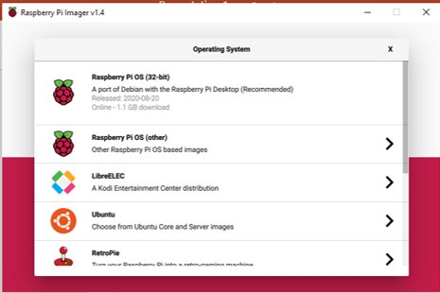

Figure 4: Image of Raspberry Pi OS being installed

**Subtask 2.3 - Set up any more other configurations**

After the necessary components for the raspberry pi were obtained, various testing pictures were taken with the raspberry pi. Taking pictures is essential for the project because they will be needed to take images of the oyster shells. Since, at this point, the oysters had not arrived yet, pictures of everyday items in the tank were taken instead to ensure the camera was working. . ​

The figure below, Figure 5, shows testing images taken with the raspberry pi camera.

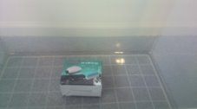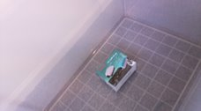

Figure 5: Test Images

In the raspberry pi terminal, a module called “pycamera” was downloaded. This gives the necessary packages to take pictures. ​The following image, Figure 6, depicts this module being downloaded.

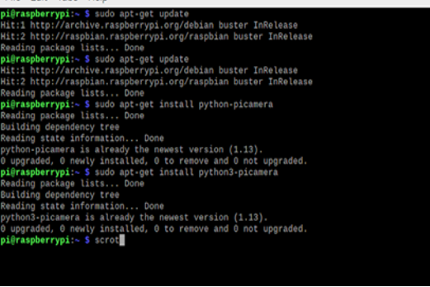

Figure 6: Necessary Packages Being Installed

**Task 3: Design software for oyster identification:**

In this task, the necessary steps are taken in order to begin training the neural network for oyster identification. This will make sure that the camera is capable of identifying the oyster in the tank.

The objective of this task is to create an image processing program via python and google collaborate that is able to identify if an image is an oyster or not.

**Subtask 3.1: Photo dataset preparation**

To prepare for the program to be created, images must be taken for the training dataset and testing dataset. This will help the model become trained more accurately because it has a large amount of data that it will be based off of.

150 images of oysters were taken and put in a folder, and 150 images of miscellaneous household items were taken and put in a folder.This was for training purposes. Later, the same process was repeated for testing purposes.

The figure below, Figure 7, depicts the folder full of the images for the training and testing folder for images of the oysters.

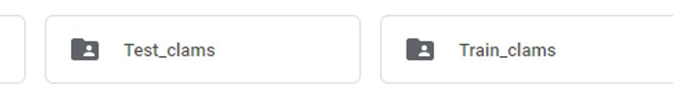

Figure 7: Testing and Training Folder Image

**Subtask 3.2: Develop a baseline CNN**

In order to create an image processing program, convolutional layers in a neural network must be used. Convolutional layers are layers in a neural network that notice patterns in images that help us identify an image. They help with image processing by us being able to determine which image is an oyster because of the similarities in pattern in images.

Convolutional layers consist of input layers, hidden layers, and output layers. The input layers consist of how many categories we plan on feeding to the neural network. The hidden layers are the various amounts of different patterns in the image that the algorithm picks up on. The CNN originally was created with 30 nodes in the input layer and 30 nodes in the output layer,

but the nodes were later increased to 50 nodes in the input layer and output layer and 50 nodes in the output layer. There are also 10 hidden layers in between these input and output layers.

The following figure, Figure ___, depicts how the convolutional neural network works.

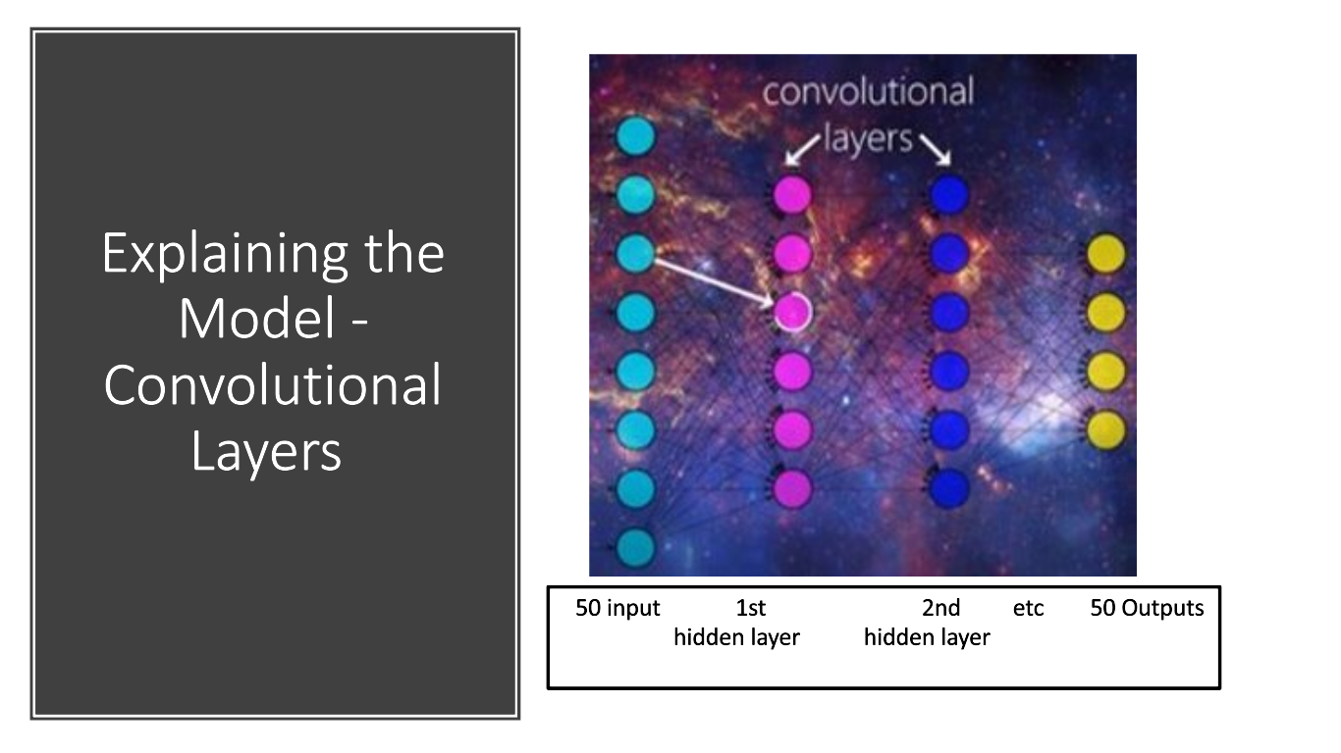​

Convolutional layers work as detectives essentially. When analyzing a picture, they scan the image for various different features that the image of an oyster has.

The oyster has many different features including their curved edges, the various grey and white shades on the shell, and the oval looking shape. The features in the image are scanned. If a feature is found that matches what the image is looking for, then it is classified as an oyster. If not, it will be ignored by the camera. This process goes on continuously for all of the images in our training folder. ​

**Subtask 3.3: Train CNN Model**

For this program, there are 2 categories – images of oysters in water, and images of sometime else, AKA non-oysters. For the pictures of oysters in water, there are 150 images of oysters in water and 150 images of other miscellaneous pictures. Many pictures of the empty tank with just water were included also, so the model would be able to determine the parts of the tank that are just water versus the parts of the tank with an oyster in it. The training parameters were then defined to be able to give an accuracy number that would determine how well the training model worked. The training model went through 30 "epoches'', which are 30 passes that the dataset completed. When the code is run, it also will display the amount of images identified out of the testing folder, and the epoches, or passes it went through. It will also display the training loss and the testing loss. As described on the official "keras FAQ", THE training loss is the average of the losses over each batch of training data. Since the model is changing over time, the training loss over the first batches is generally higher, while the testing loss is generally lower over the last batches. ​The following figure, Figure 8, depicts the training parameters for the model.

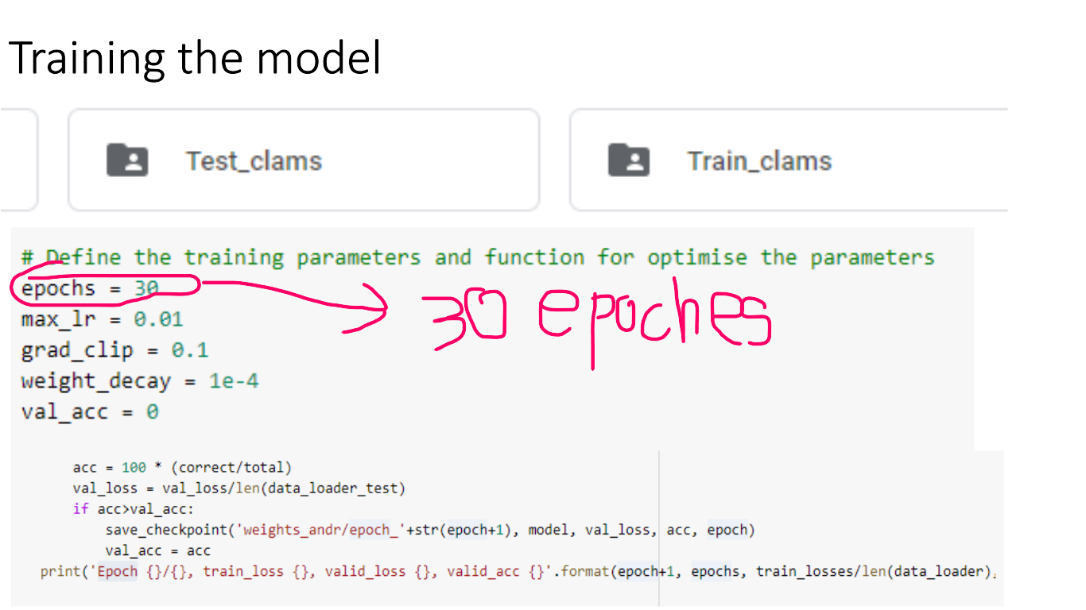

Figure 8: Training Parameters for Model

When running the code, the model was trained and data was received from the training. The following figure, Figure 9, depicts the data received when running the code.

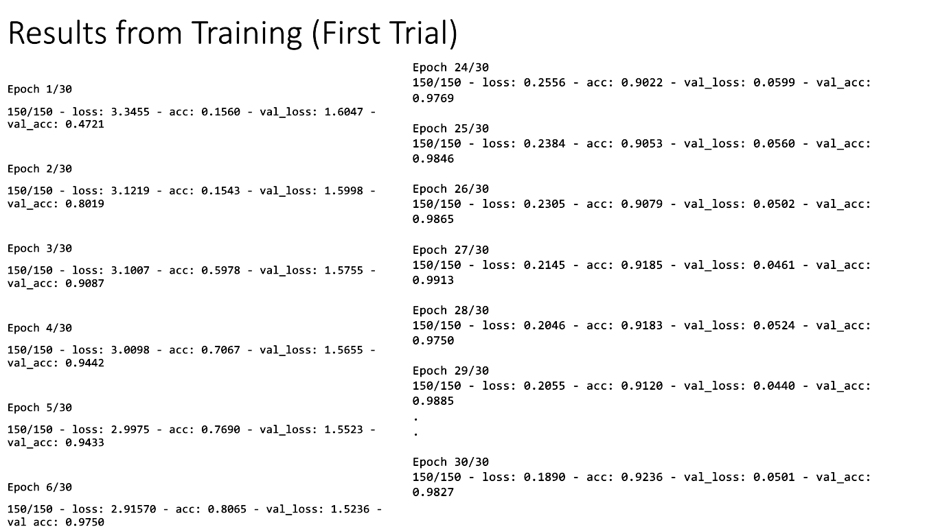

Figure 9: Data recieved when running training code

The training loss, which is supposed to significantly decrease over the first couple epoches, did not change much at all. As it did decrease, it did not decrease by much. The training loss only decreased from a range of 1.1647 to 1.5236 within the first 6 epoches, also ended with a final training loss of 1.5013. Also, with the testing loss, which is supposed to significantly increase over the last couple epoches, did not change much at all. As it did increase, it did not increase intensely. The testing loss only increased from a range of 0.9769 to 0.9885 within the last 6 epoches, and also ended with a final testing loss of 0.9897 , compared to the testing loss at the beginning which was 0.9022 . After this training, this image processing program was imported into another code which is meant to determine how many images of oysters vs non oysters are in the folder. ​

When the code that obtains image processing is run, the code prompts the user to type the file destination of the testing folder. This folder has 150 images, with 75 of them being images of oysters and 75 of them being non oyster images. The results will then show many images were oyster images vs how many images were non oyster images. This will be ran 10 times and all results will be recorded for an accuracy of the training model ​

The following figure, Figure 10, depicts what the code being run will look like.

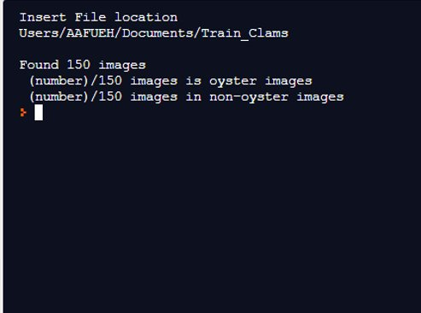

Figure 10: What code looks like when ran

The following figure, figure 11, depict the results for the first trial for testing the data.

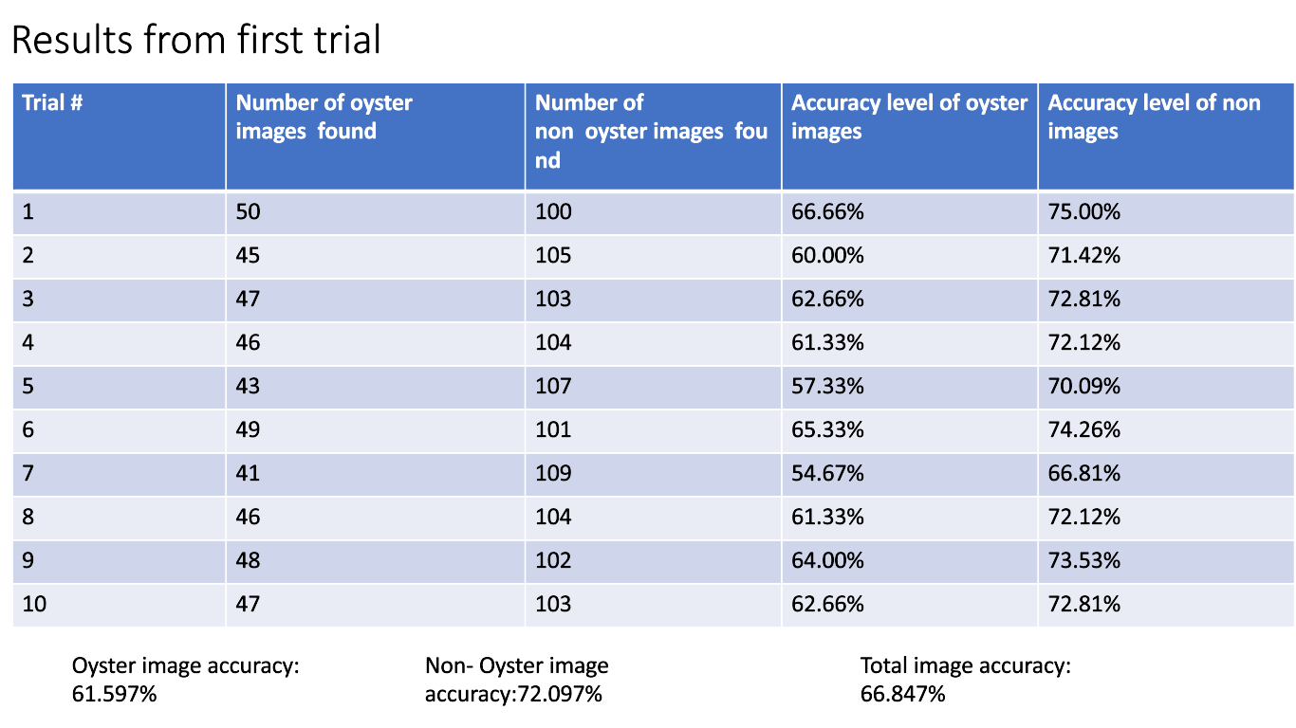

Figure 11: Results for first trial testing

The accuracy level of identifying the oyster images came out to a total of 61.597% while the accuracy level of identifying the non oyster images came out to a total of 72.097%. It can be inferred from this data that the image processing program is not very strong nor accurate. Thus meaning that the CNN model must be improved.

**Subtask 3.4: Improvement on CNN model**

Because of the poor performance in the image processing results, more nodes were added to the layers in the neural network.. Instead of 30 nodes in the input and output layer, there was now 50. 20 more nodes were added to the image processing code. These nodes identify the color, texture and shape of the oyster in the image much more specifically. The image processing code was then retrained and retested again.​

The following figure, Figure 11, depicts the results from the second training model.

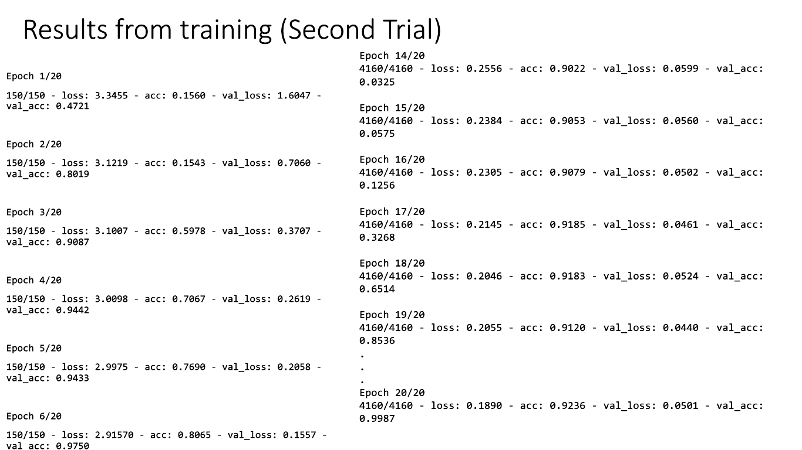

Figure 11: Results from second training model

The results from the training model are much more accurate in the second trial, now that it has more nodes. The training loss significantly decreased within the first few batches. ​

The training loss decreased from a range of 1.6847 to 0.7060 within the first 6 epoches. It also ended with a final training loss of 0.0501, which is a significant decrease compared from its original training loss which was. Also, the testing loss significantly increased within the last 6 epoches. The testing loss increased from a range of 0.0325 to 0.8536. It also ended with a final training loss of 0.9987, which is a significant increase compared from its original training loss which was 0.0325​.

**Subtask 3.5: Finalize CNN Model**

Now that the model has been trained much better, it can now be finalized and tested for its accuracy.

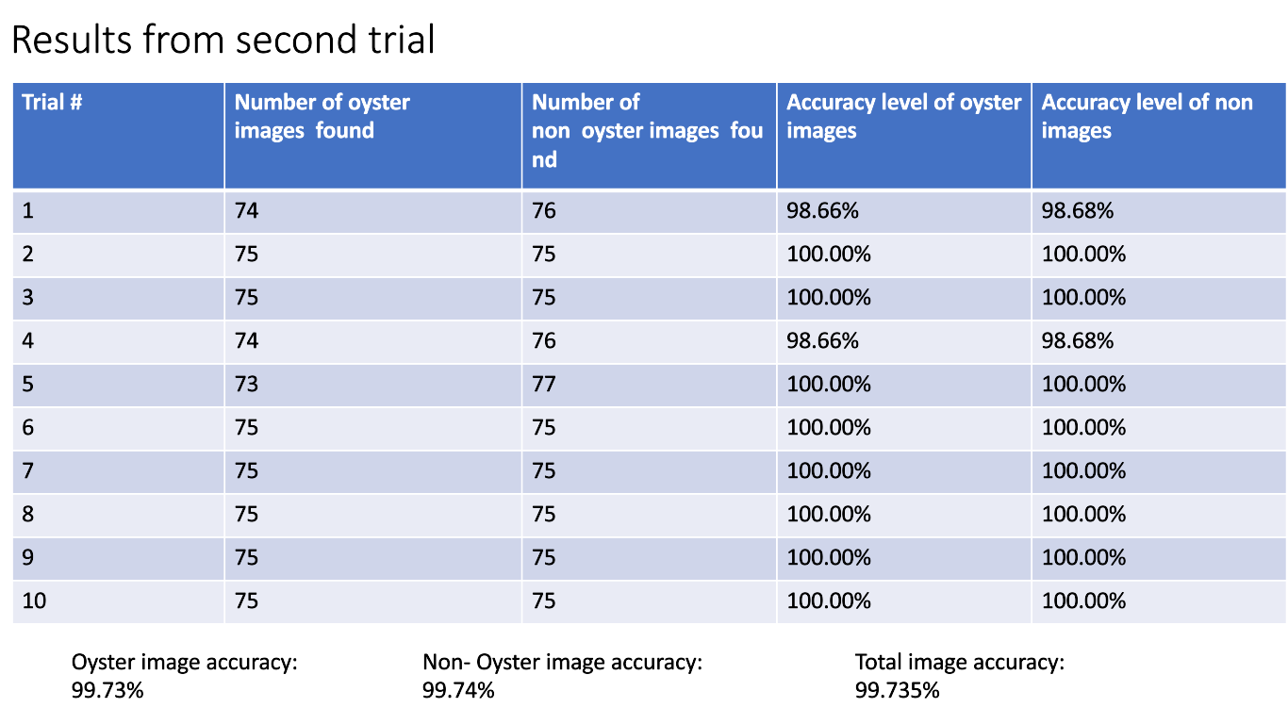

Figure 12: Results from testing

The model was then tested the second time around. The oyster image accuracy is now 99.73%, the non oyster image accuracy is now 99.74% and the total image accuracy is now 99.735. This ensures that the model has vastly improved its performance and is working very accurately. ​

**Task 4: Design software for oyster activity level**

In this task, the necessary steps are taken in order to begin training the neural network for oyster position identification. This will make sure that the camera is capable of identifying the position of the oysters in the tank.

The objective of this task is to create an image processing program via python and google collaborate that is able to identify whether the oyster is in an open position or closed position. Also, if the oyster is in an open position, the program will tell us whether it is in a largely open position or small opened position.

The following figure, Figure 13, depicts essentially what the image identification software for the oyster activity level will emulate.

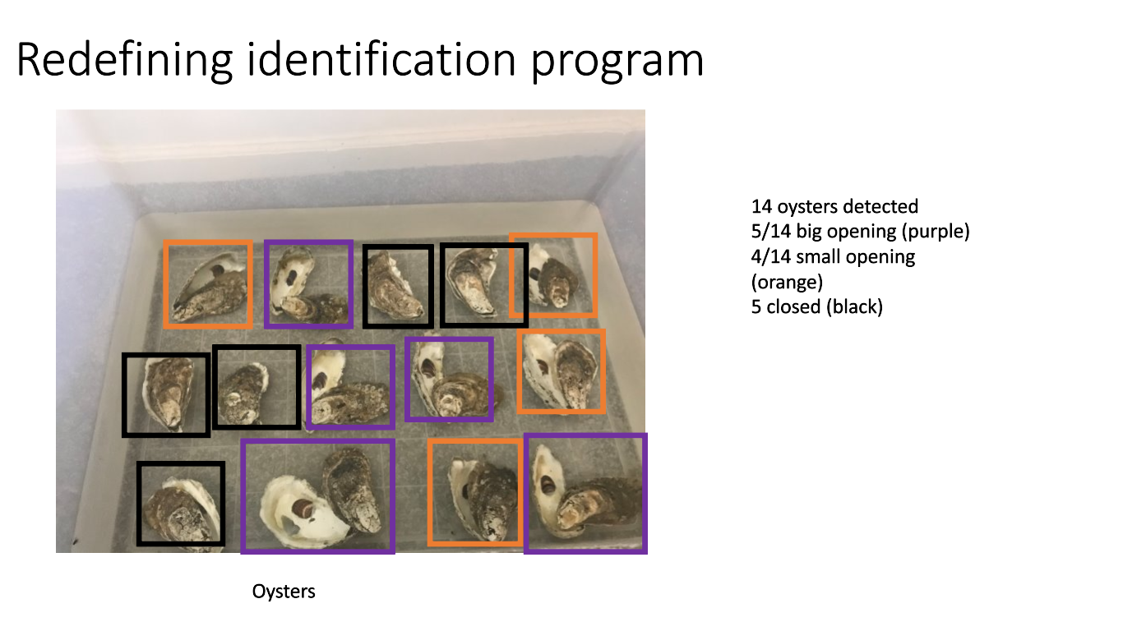

Figure 12: What Image Identification software will emulate

There are 3 categories of positions that the oysters in the tank can be – closed, a big opening, or a small opening. The program is trained such that each of these 3 categories are able to make the program identify the oyster's position. The following figure, Figure ___, depicts the 3 different categories of oyster positions.

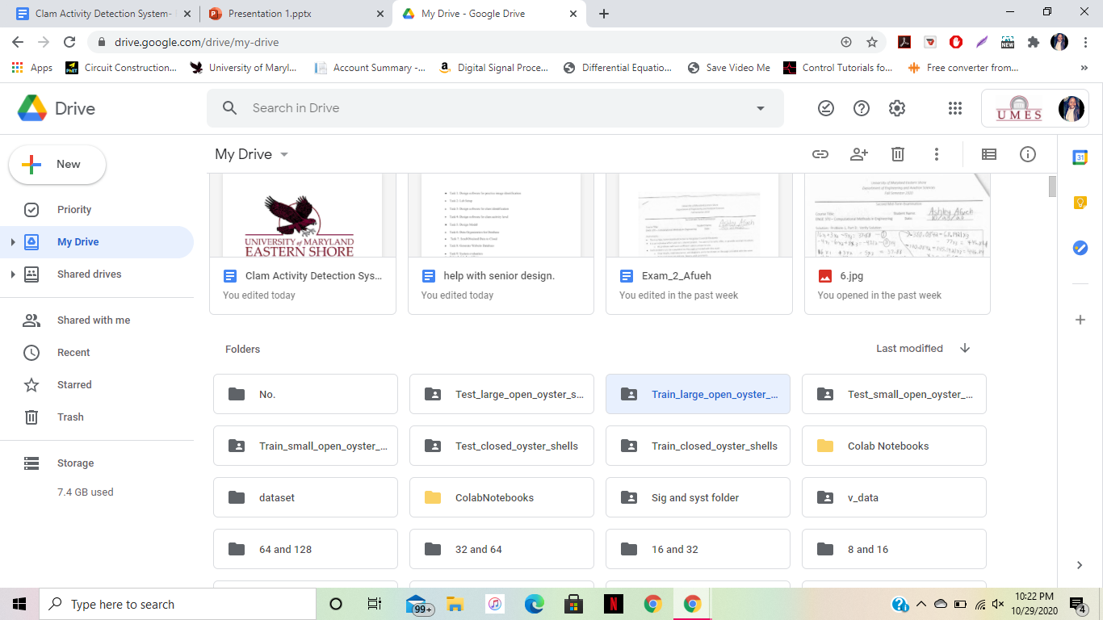



**Subtask 4.1: Photo Dataset Preparation**

In this subtask, the photo dataset was prepared. There needs to be datasets for the training portion of the program and the testing portion of the program. First 200 images of each category of oysters in the tank were taken.. There were 200 images of closed oysters in the tank, 200 images of oysters in the tank with a big opening, and 200 images of oysters in the tank with a small opening. Each category was trained one at a time and then combined the training at the end of the program in order to be able to identify the oyster's position​. The following figure, Figure ___, depicts the 6 different folders used for the photoset data preparation. 3 of the folders are for testing while the other 3 of the folders are for training.

**Subtask 4.2: Develop a baseline CNN**

During this task, we developed a convolutional neural network that is capable of identifying the various different positions of the oysters. The hidden layers in this network identified different characteristics of the images of the oysters in order to be able to determine its position. Some of the layers in the neural network use color and shape to identify whether there are oysters in the image at all. Some hidden layers catch all of the various colors of the image, and if the image's color matches that of an oyster, then it is identified to be an oyster. If the color is not identifiable, it is not identified and considered extra space in the tank. ​Other hidden layers identify the shape of the oyster. Regardless of whether the oyster is opened or closed, the goal of hidden layers like these is just to identify that there is an oyster there in general. ​The figure below, Figure ___, depicts what the hidden layers described above are looking for.

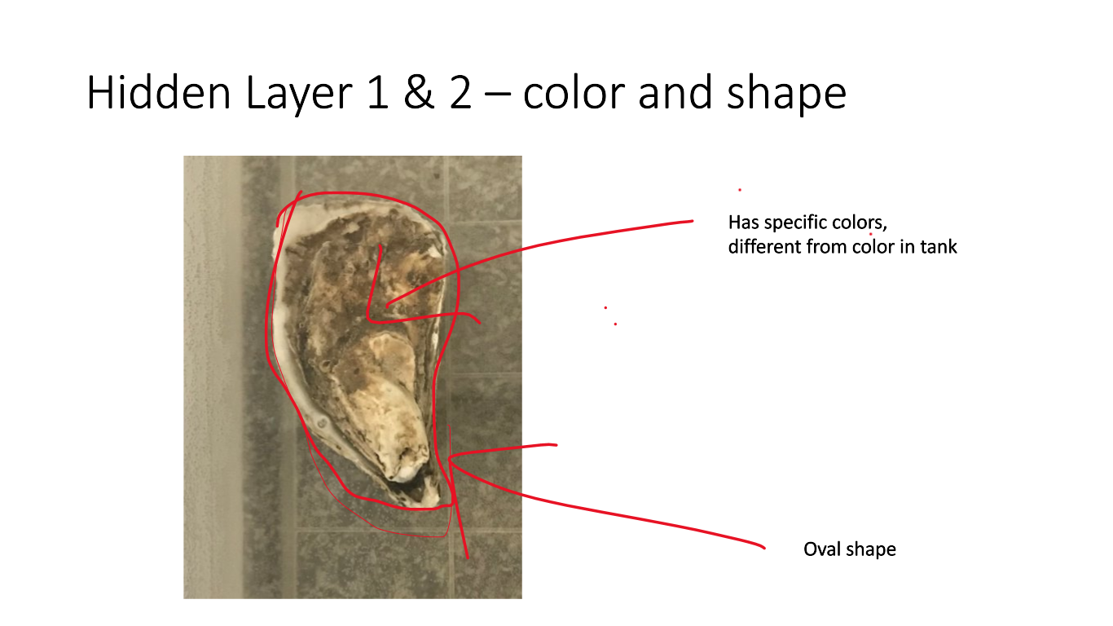

This layer identifies whether the oysters are opened or closed in general. If the oyster has its regular oval shape, it will identify as a closed oyster. But if the oyster has a shape that is larger than an oval, and has more of a heart shape, then it will identify as open. This is an extremely important step in the hidden layers because this step will help to identify whether the oyster is opened or closed. When closed oysters are identified, then are done going through the neural network. Open oysters however, must keep going through all the layers until they are identified as big or small oysters. ​The following figure, Figure ____, depicts what characteristics these hidden layers are looking for.

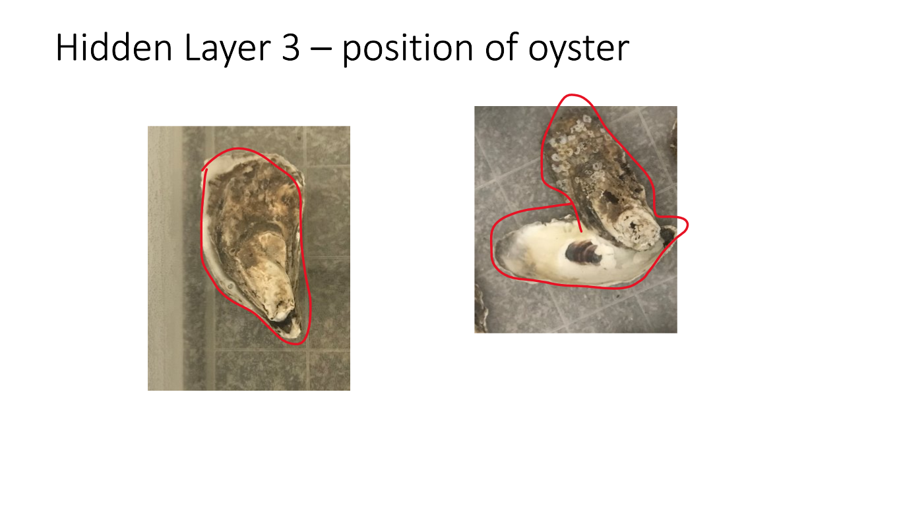

There are also hidden layers that determine if the opening is a big or small opening. It determines if there is a space between the two opened shells where you can see a part of the tank or not. If the space on the ground can be seen, then it is a big opening. If not, then it is considered a small opening. ​The following figure, Figure ____, depicts the difference between a large and small opening.

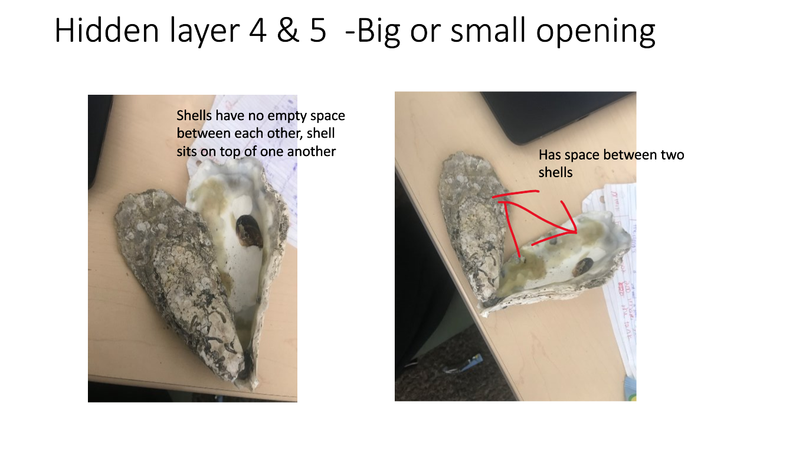

**Subtask 4.4: Improvement on CNN model**

To train the model, there are 3 categories, closed, a big opening or a small opening. There are 200 images of each category for the testing, and 200 images in each category for the training. Many pictures of the empty tank with just water were included so the model would be able to determine the parts of the tank that are just water versus the parts of the tank with an oyster in it. The training parameters were then defined to be able to give an accuracy number that would determine how well the training model worked. The training model went through 30 "epoches", which are 30 passes that the dataset completed. When the code is run, it will also show how the images in the testing folder were identified, and the epoches, or passes it went through. It will also show the training loss and the testing loss. As described on the official "keras FAQ", the training loss is the average of the losses over each batch of training data. Since the model is changing over time, the training loss over the first batches is generally higher, while the testing loss is generally lower over the last batches. ​

Since the model is changing over time, the training loss over the first batches is generally higher and decreases significantly, while the testing loss is generally lower over the last batches and increases drastically. The following figure, Figure ___, depicts the results for training the model for oysters in the closed position.

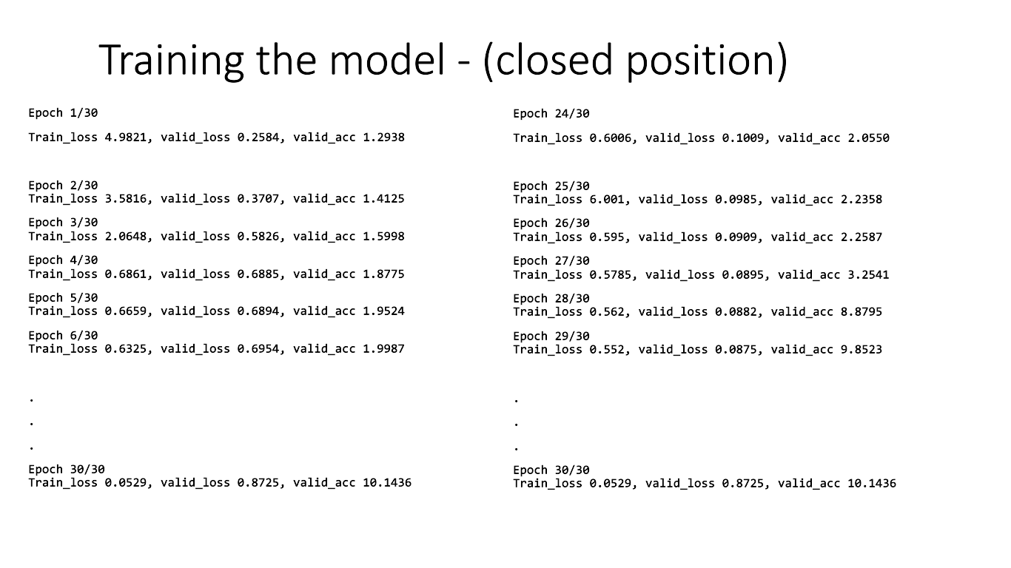

Training stops when the testing loss (which is labeled "val_acc") stops increasing, otherwise the model will probably overfit and give us inaccurate results. The training for the closed position went well, seeing as how the training loss decreased from 4.9821 to 0.6325 in the first 6 epoches, and the testing loss increased from 1.2938 to 9.8523 in the last 6 epoches . The same two things happened for the big opening position and small opening position. ​

To test the data, 14 pictures were taken of the tank with oysters at varying positions. To test the data, there were 12 trials of the oysters in varying positions – in each different trial, the oyster was in a different position. This way, the program could test whether the model can identify each oyster regardless of the position that the oyster may be in. The table shows the various positions that the oysters were in for the testing. ​

The following figure, Figure ___, depicts how the positions of the oysters will be during the testing. 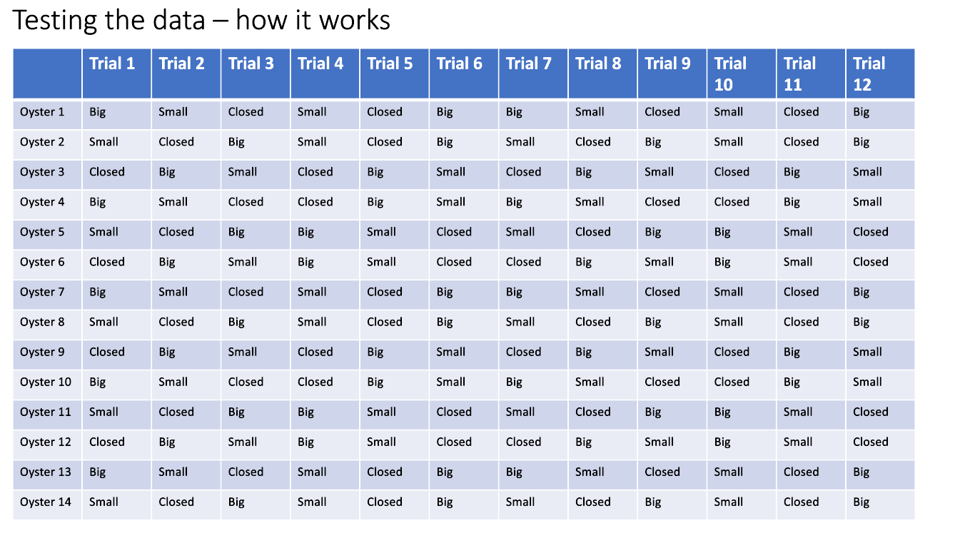

The following figure below, Figure ____, depicts the results from the 12 trials.

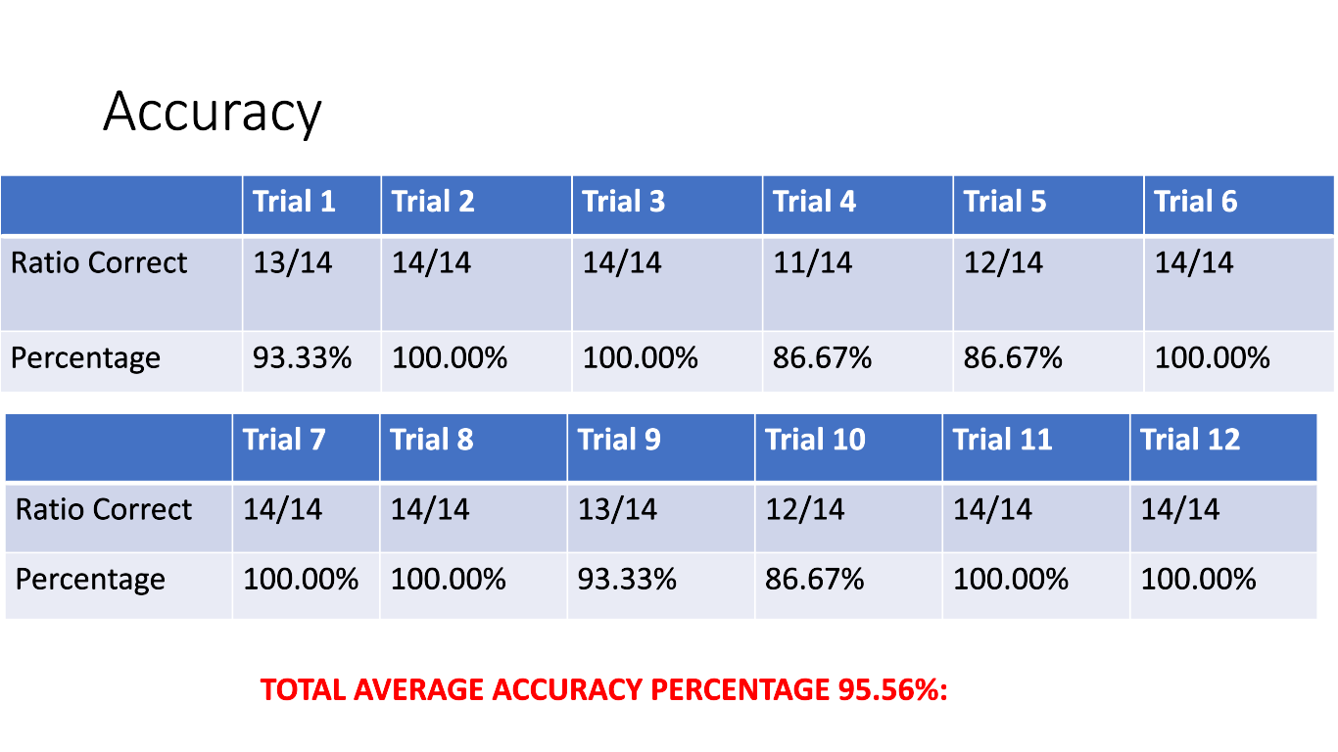 Trials 2, 3, 6, 7, 8, 11, and 12 have 100% accuracy. Meanwhile, trial 1 and 9 incorrectly identified 1 oyster position, resulting in 93.33%. Trial 4, 5, and 10 incorrectly identified 2 oyster positions. After this, the neural network was retrained and more layers were added to the neural network to make sure the neural network is trained a little better because the goal for the program was an accuracy of 99 percent, not 95.56%.

The program was then retrained using the same process, but with more nodes. The total average accuracy percentage came out to be 90.54%, which is even worse than the accuracy percentage from the beginning of the training. It was then found that during the training of the neural network for the second trial, the training model “overfitted”, meaning it was overtrained and the testing loss increased too much during the training. To avoid this, the amount of nodes in the hidden layers was reduced and the amount of layers in the neural network was increased.

**Subtask 4.5: Finalize the Model**

When the program ran, it then gave an accuracy percentage of 98.3%, which is very close to what the goal for the accuracy was.

**Task 5: Data Organization for Database**

In this task, the system will be run and the data collected from the system will be organized and distributed for the database. This part of the task is important because it distinctively categorizes the results of the image processing program so it can be understandable and transferable for the database.

**Subtask 5.1: Sorting Data Files**

In this task, the program was run, and the results from the data were sorted depending on its category. When the image processing program is running, a picture from the live stream video of the oyster shells is taken every 1 minute. The program will analyze this picture and then show results. These results will include reports of how many oysters were detected overall, which oysters were closed, slightly open, and largely open. (Keep in mind that the oyster shells’ position can be manually changed). Since there are 60 minutes in 1 hour, the program will show 60 results within an entire hour, and then open up a different command window for the next hour. From here on forward, the 60 results in 1 hour will be referred to as a “cycle”. For example, 12am to 1am could be considered “cycle 1”, 1am to 2am could be considered “cycle 2”, so on and so forth. The 60 results in the cycle have 3 different categories; closed, slightly open or largely open.

The following figure, Figure ____, depicts what the first 4 results in cycle 1 will look like.

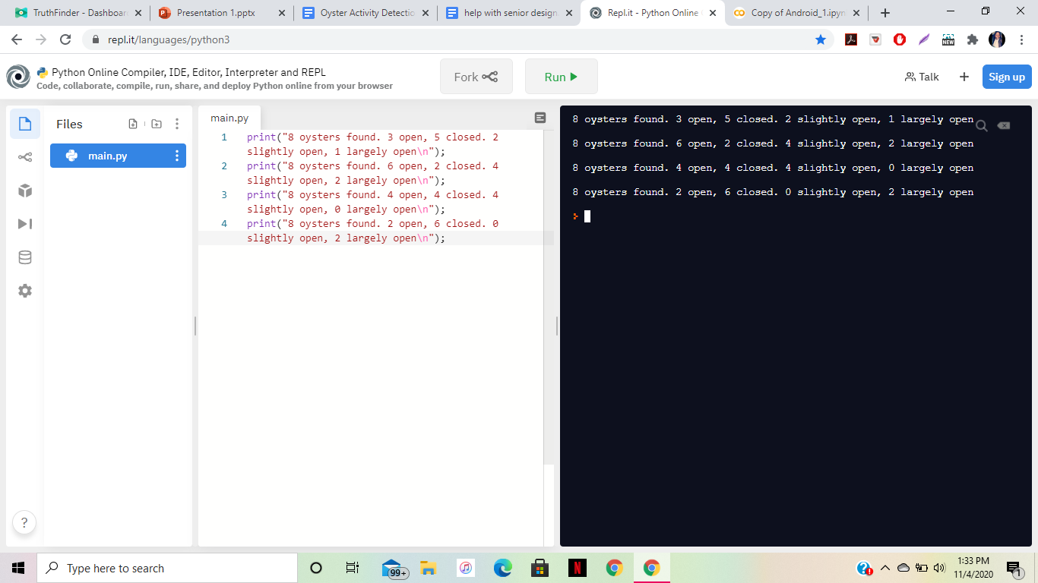

**Subtask 5.2: Writing Data to a File**

The results for this data were then written into a google sheets spreadsheet. A google sheets spreadsheet is very similar to a microsoft excel spreadsheet, but google sheet spreadsheets are much more compatible with the website database being used to display our results.

**Subtask 5.3: Modeling Data for Database**

In order for the results to be displayed accurately on the website, they first must be separated into different categories on the spreadsheet, and then modeled by a bar graph. Since the program runs on an 18 hour basis, there will be 18 cycles. Each cycle will have its own spreadsheet. The following figure, Figure ___, depicts what the spreadsheet for 1 cycle will look like. 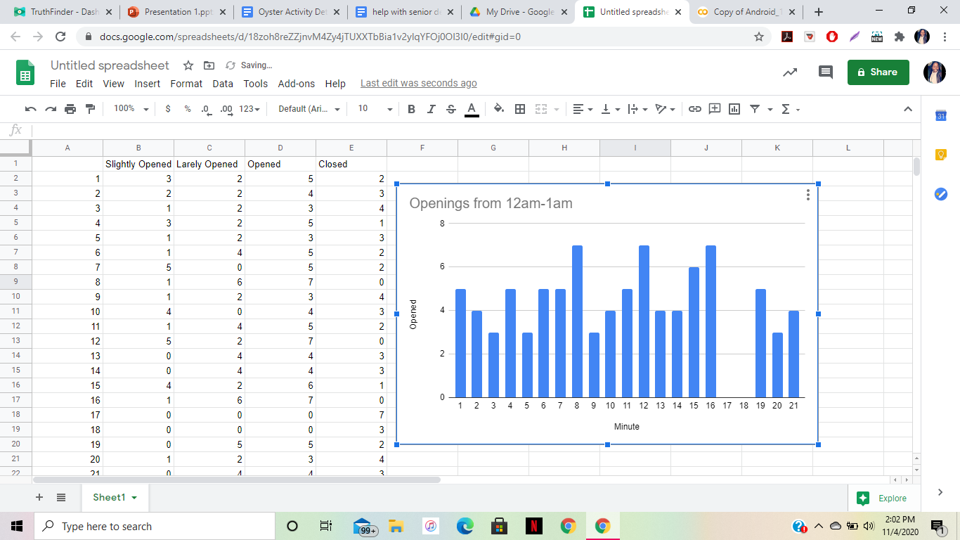

There are 4 different columns, one for closed, one for total opened oysters, one for slightly open oysters, and one for largely open oysters. Each of the three columns have a bar graph created that depicts how many oysters were open or closed during that cycle, and whether the oysters had a large or small opening. The following figure, Figure __, depicts what the columns and bar graphs look like.



**Subtask 5.4: Generate code to put obtained data to website**

In this step, the bar graphs from the spreadsheet were embedded. The embedded code was copied and stored to later be put into a website.

**Task 6: Generate Website Database**

In this task, the website was generated using a free website database. This website obtains all of the information regarding the oyster activity levels. They are displayed on an 18 hour basis with hourly increments. This task is important because the user will have a way to visually view the data and extrapolate essential data needed from that data. This data will be embedded from a file from google sheets, which is a data source that we will use with the project due to it being compatible with the code we use for this project, and free of cost. ​

**Subtask 6.1: Organize Layout for Website**

There are 3 categories of data that will be shown: Total openings, Oyster openings per hour, and the level of openings. They all will be shown over an 18 hour period, with hourly increments, even though the data will be continuously running. The following figure, Figure ___, depicts the different tabs that depict the different categories of positions.

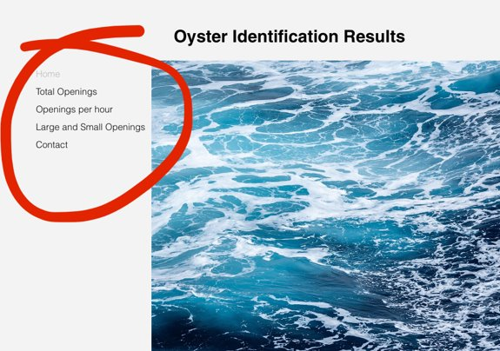

As it can be seen, the first tab displays the total amount of openings over the 18 hour basis. The second tab displays 18 different graphs depicting how many openings the oysters had during that hour. It shows 1 hour data for the time frame of 12am to 6pm. It resets every 18 hours, starting from 12am. To the right of each graph, it displays the total amount of openings during that time period. The third tab displays the large and small openings per hour out of all the openings that the oysters had within that hour. And the fourth tab simply displays the contact information for any difficulty issues.

**Subtask 6.2: Upload Data for General Oyster Activity and Activity Level**

In this subtask, the graphs for the amount of oysters that were open were embedded into the second tab. One by one, each graph for each hour was embedded into the website. In order to embed the graph into the website, the three dots at the top right corner of the graph are clicked, and from there “publish” is chosen. This link gives an embedded link. This embedded link is copied and pasted into the website, via the “embed” command. When embedded, the graph can now be displayed on the website and changes to the data will reflect on the website as well. Also, the total amount of openings during that hour was also embedded into the website. The following figure, Figure ___, displays the embedded link and the link being copied to be put into the website.

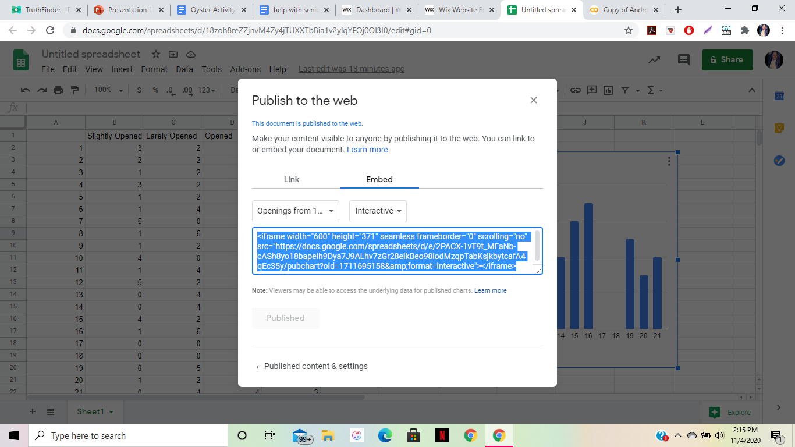

**Subtask 6.3: Upload Data for Individual Oyster Activity and Activity Level**

In this subtask, the same steps for subtask 6.2 were repeated, except for it was for small openings and large openings. The graphs for the amount of oysters that had large openings and small openings were embedded into the second tab. One by one, each graph for each hour was embedded into the website. In order to embed the graph into the website, the three dots at the top right corner of the graph is clicked, and from there “publish” is chosen. This link gives an embedded link. This embedded link is copied and pasted into the website, via the “embed” command. When embedded, the graph can now be displayed on the website and changes to the data will reflect on the website as well. Also, the total amount of openings during that hour was also embedded into the website. The following figure, Figure ___, displays the embedded link being copied to be pasted into the website.



**Subtask 6.4: Run Website, Fix errors**

In this subtask, the website was finalized, and ran. The website was also checked for any errors with data or issues with displaying results. When no errors were found, it was realized that the website was in great condition.

**Task 7: System Evaluation**

In this task, the system was run 10 times, with each time being over an 18 hour period. It can be inferred that this was a rather tedious task that took about a week. The accuracy levels of the program were determined. When determining the accuracy levels, this includes the accuracy levels of the output of the image processing program, and the output of the website. All aspects of the image processing system will be thoroughly inspected in order to ensure that they are all working properly.

**Subtask 7.1: Test Entire System**

The program was run through 10 trials. Each time the program was run, it was tested for accuracy. First, the image processing code was run. It is programmed to run consistently while resetting every 18 hours. For each 10 times, the accuracy percentage was calculated for each trial, then the average accuracy level from these 10 times was calculated.

First, the python code was run on the raspberry pi operating system, which activated the continuous livestream of the clams. The following figure, Figure ___, depicts a screenshot of the livestream from the raspberry pi camera.

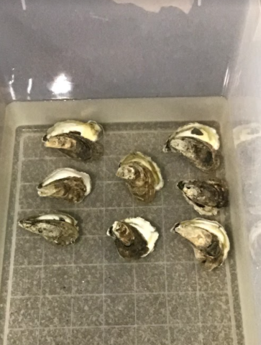

As the code is running, every 60 seconds, a picture is taken and then the image processing code gives an output of how many oysters were opened or closed, and which opened-shelled oysters had small openings versus large openings in the command window. It should be noted that every couple of minutes, the oyster shells will be manually changed by hand. After an entire hour, there are 60 outputs in the command window. These 60 outputs are uploaded into the google sheets excel sheet. After 1 hour, all 60 of the outputs in that hour are in the spreadsheet. The website then updates the hourly data, when the google spreadsheet is finished for the hour. The website depicts how many total openings there were per hour and which openings were big or small.

This process was repeated 10 times.

**7.2: Determine Accuracy Percentage**

Once the code was run 10 times, the accuracy levels of the image processing code was calculated. It can be noted that the accuracy of the entire system is ___%. This is very close to our goal, which is ____.

1. **Project evaluation**
2. Public health/Environmental factors

Monitoring oyster activity can assist greatly in helping to clean dirty and tarnished oceans across the globe. Since oysters have the ability to clean the water they have grown in my filter feeding, monitoring oyster activity can assist public health by determining the factors that they thrive best in. After determining these factors, this information can be utilized to move oysters to environments they thrive best in. In return, they will filter and clean the water around them, helping with clean water supply in the environment.

1. Safety/Welfare

In previous methods of oyster identification, many biologists and ecologists had to touch the oysters manually and check their shell openings manually. The method that was created in this project for oyster activity does not require consistent manual touching of the oysters, seeing as how their position will be determined by camera. Since there is minimal human contact with the oysters, this reduces the possibility of bacteria and/or other dangerous germs transferred from the oysters to humans. This program assists in safely tracking the opening of the oyster shells while still maintaining the welfare of the biologists and ecologists.

1. Global factor

Monitoring oyster behavior can positively affect how ecologists conduct research for oysters. Since these ecologists now have a means of monitoring oyster activity, they can use this to conduct experimental research regarding how various factors in oyster environments affect oyster development.

1. Economic factor

Previous methods for oyster research include methods requiring various sensors. These sensors require more electrical power to work. In this project, the only thing that was used to monitor clam activity was a raspberry pi camera. Seeing as how only one electrical component was used to determine oyster activity instead of multiple electrical components, the program is much less costly. Using this system to determine oyster activity is a much cheaper and more economical way to conduct research regarding oyster activity.

1. **Conclusion**

* Project summary

Conclusively, this project was about using image processing in order to develop a system that identified oyster activity. In this project, a problem was identified and by using engineering problem solving techniques, it was solved. The problem that was identified was that the University of Maryland Eastern Shore’s food and technology department struggled with being able to track oyster activity to determine oyster development. In order to solve this problem, a SMART image processing system was created such that a continuous live stream of the oyster shells were created, and the position of the oyster shells could be identified. This way, when these oyster shells are replaced with live oysters, their openings can be identified easily, as well as the type of openings they have. A website was created in order to display the results for the oyster activity as well.

* Learning and practice experience

In this project, we gained hands-on experience with many different engineering methods that are used for problem solving.

One of these methods include image processing. Image processing is done when a code is programmed to be able to process an image. Throughout various tutorials, former online projects, and python coding manuals, we learned how to write a python script that can process an image, and determine what an image consists of. We learned about how computers read images by their pixels, and break them down into even smaller pictures in order to find patterns throughout the image that can be traced and found in other pictures. We also learned how to create a neural network, which is essential for image processing. There was so much experience gained in how neural networks work, how they are trained, how they are tested, and how they are processed. This neural network was the algorithm that helped decide what position the oysters are in when pictures are being taken of them.

Another problem solving method we learned about is extrapolating data to be eligible for interpretation. When receiving all of the results for the image processing program in the outcome of the program, we needed to find an easily understandable way to interpret this data such that it would be easy to understand for the user. We figured out what would be the best way to express the data that was found and came up with designing a website with embedded data from a spreadsheet to display the data that displays their oyster activity.

* Future plan (how to improve)

There are various ways to improve this project.,

One of the main ways to improve this project is to use actual oysters, and not oyster shells. The reason for this is because there would be authentic data collection from real, live oysters themselves and not oyster shells. Also, another way to improve this project would be to find a better way for filtration within the tank. After a few days, the water from the tank becomes less clear due to there being no filtration in the tank.

**Acknowledgment**

We would like to take this time to thank many of the various online references including stackoverflow, keras FAQ, python FAQ, and youtube for giving us resources for help for our project.

**Appendix**

**Source Codes:**

1. ***Source Code of practice code***

import tensorflow as tf

from tensorflow import keras

from tensorflow.keras import layers

import os

#>>>>>>>>>>> Step 1

num_skipped = 0

for folder_name in ("cars", "planes", "random (other)"):

folder_path = os.path.join("train", folder_name)

for fname in os.listdir(folder_path):

fpath = os.path.join(folder_path, fname)

try:

fobj = open(fpath, "rb")

is_jfif = tf.compat.as_bytes("JFIF") in fobj.peek(10)

finally:

fobj.close()

if not is_jfif:

num_skipped += 1

# Delete corrupted image

os.remove(fpath)

print(fpath)

print("Deleted %d images" % num_skipped)

#>>>>>>>>>>> Step 2

image_size = (224, 224)

batch_size = 32

train_ds = tf.keras.preprocessing.image_dataset_from_directory("train",validation_split=0.10,subset="training",seed=1337,image_size=image_size,batch_size=batch_size)

val_ds = tf.keras.preprocessing.image_dataset_from_directory("train",validation_split=0.10,subset="validation",seed=1337,image_size=image_size,batch_size=batch_size)

data_augmentation = keras.Sequential(

[

layers.experimental.preprocessing.RandomFlip("horizontal"),

layers.experimental.preprocessing.RandomRotation(0.1),

]

)

train_ds = train_ds.prefetch(buffer_size=32)

val_ds = val_ds.prefetch(buffer_size=32)

#>>>>>>>>>>> Step 3

def make_model(input_shape, num_classes):

inputs = keras.Input(shape=input_shape)

# Image augmentation block

x = data_augmentation(inputs)

# Entry block

x = layers.experimental.preprocessing.Rescaling(1.0 / 255)(x)

x = layers.Conv2D(32, 3, strides=2, padding="same")(x)

x = layers.BatchNormalization()(x)

x = layers.Activation("relu")(x)

x = layers.Conv2D(64, 3, padding="same")(x)

x = layers.BatchNormalization()(x)

x = layers.Activation("relu")(x)

previous_block_activation = x # Set aside residual

for size in [128, 256, 512, 728]:

x = layers.Activation("relu")(x)

x = layers.SeparableConv2D(size, 3, padding="same")(x)

x = layers.BatchNormalization()(x)

x = layers.Activation("relu")(x)

x = layers.SeparableConv2D(size, 3, padding="same")(x)

x = layers.BatchNormalization()(x)

x = layers.MaxPooling2D(3, strides=2, padding="same")(x)

# Project residual

residual = layers.Conv2D(size, 1, strides=2, padding="same")(

previous_block_activation

)

x = layers.add([x, residual]) # Add back residual

previous_block_activation = x # Set aside next residual

x = layers.SeparableConv2D(1024, 3, padding="same")(x)

x = layers.BatchNormalization()(x)

x = layers.Activation("relu")(x)

x = layers.GlobalAveragePooling2D()(x)

if num_classes == 2:

activation = "sigmoid"

units = 1

else:

activation = "softmax"

units = num_classes

x = layers.Dropout(0.5)(x)

outputs = layers.Dense(units, activation=activation)(x)

return keras.Model(inputs, outputs)

from os import path

#>>>>>>>>>>> Step 4

epochs = 10

savedFileName = "save_at_{0}.h5".format(epochs)

if(not(path.exists(savedFileName))):

model = make_model(input_shape=image_size + (3,), num_classes=3)

keras.utils.plot_model(model, show_shapes=True)

callbacks = [

keras.callbacks.ModelCheckpoint("save_at_{epoch}.h5"),

]

model.compile(

optimizer=keras.optimizers.Adam(1e-3),

loss="binary_crossentropy",

metrics=["categorical_accuracy"],

)

model.fit(

train_ds, epochs=epochs, callbacks=callbacks, validation_data=val_ds,

)

model = keras.models.load_model(savedFileName)

#>>>>>>>>>>> Step 5

carCount = 0

planeCount = 0

othersCount = 0

for folder_name in ("cars", "planes", "random (other)"):

folder_path = os.path.join("train", folder_name)

for fname in os.listdir(folder_path):

fpath = os.path.join(folder_path, fname)

img = keras.preprocessing.image.load_img(

fpath, target_size=image_size

)

try:

img_array = keras.preprocessing.image.img_to_array(img)

img_array = tf.expand_dims(img_array, 0) # Create batch axis

predictions = model.predict(img_array)

predictions = predictions[0]

if(predictions[0] > predictions[1] and predictions[0] > predictions[2]):

carCount = carCount + 1

elif(predictions[1] > predictions[0] and predictions[1] > predictions[2]):

planeCount = planeCount + 1

elif(predictions[2] > predictions[0] and predictions[2] > predictions[1]):

print(fpath)

othersCount = othersCount + 1

finally:

fobj.close()

print("car Count : ", carCount)

print("plane Count : ", planeCount)

print("others Count : ", othersCount)

***2. Source code for first image processing code (from Task 3)***

!unzip Train_clams-20200930T172307Z-001.zip

!unzip Train_other-20200930T172345Z-001.zip

!pip install pyheif # version 0.5.1

!pip install PIL # version 7.0.0

!pip install numpy # version 1.18.5

!pip install torch==1.6.0+cu101 torchvision==0.7.0+cu101 -f https://download.pytorch.org/whl/torch_stable.html

## Data loader

import os

import numpy as np

import torch

import torch.utils.data

import pyheif

from PIL import Image

class RandDataset(torch.utils.data.Dataset):

def __init__(self, root, transforms=None):

self.root = root

self.transforms = transforms

# load all image files, sorting them to

# ensure that they are aligned

imgs_clams = list(sorted(os.listdir(os.path.join(root, 'Train_clams'))))

lbl_clams = np.zeros(len(imgs_clams))

imgs_other = list(sorted(os.listdir(os.path.join(root, 'Train_other'))))

lbl_other = np.ones(len(imgs_other))

self.imgs = imgs_clams + imgs_other

self.labels = np.concatenate((lbl_clams, lbl_other))

def __len__(self):

return len(self.imgs)

def __getitem__(self, idx):

# load images ad masks

if os.path.isfile(os.path.join(self.root, 'Train_clams', self.imgs[idx])):

imgs_path = os.path.join(self.root, 'Train_clams', self.imgs[idx])

if os.path.isfile(os.path.join(self.root, 'Train_other', self.imgs[idx])):

imgs_path = os.path.join(self.root, 'Train_other', self.imgs[idx])

heif_file = pyheif.read(imgs_path)

img = Image.frombytes(

heif_file.mode,

heif_file.size,

heif_file.data,

"raw",

heif_file.mode,

heif_file.stride,

)

if self.transforms is not None:

img = self.transforms(img)

lbl = self.labels[idx]

return img, torch.tensor(lbl, dtype=torch.long)

#Data Transform

import torchvision.transforms as T

def get_transform(train):

transforms = []

# converts the image, a PIL image, into a PyTorch Tensor

transforms.append(T.Resize((224,224)))

transforms.append(T.ToTensor())

transforms.append(T.Normalize([0.485, 0.456, 0.406], [0.229, 0.224, 0.225]))

if train:

# during training, randomly flip the training images

# and ground-truth for data augmentation

transforms.append(T.RandomHorizontalFlip(0.5))

return T.Compose(transforms)

dataset = RandDataset('dataset', get_transform(train=False))

dataset_test = RandDataset('dataset', get_transform(train=False))

#Split dataset into two train test

torch.manual_seed(1)

indices = torch.randperm(len(dataset)).tolist()

dataset = torch.utils.data.Subset(dataset, indices[:-20])

dataset_test = torch.utils.data.Subset(dataset_test, indices[-20:])

print(len(dataset))

print(len(dataset_test))

data_loader = torch.utils.data.DataLoader(dataset, batch_size=8, shuffle=True, pin_memory=True)

data_loader_test = torch.utils.data.DataLoader(dataset_test, batch_size=1, shuffle=False)

# Inverse Transform

import matplotlib.pyplot as plt

inv_normalize = T.Normalize(

mean=[-0.485/0.229, -0.456/0.224, -0.406/0.225],

std=[1/0.229, 1/0.224, 1/0.255]

)

def imshow(img):

img = inv_normalize(img) # unnormalize

npimg = img.numpy()

plt.imshow(np.transpose(npimg, (1, 2, 0)))

plt.show()

# Visualise Data Loader

import torchvision

imag, labl = next(iter(data_loader))

imshow(torchvision.utils.make_grid(imag))

print(labl)

## Model

import torchvision

class ResNetBackbone34(torch.nn.Module):

def __init__(self, out_filters=2):

super(ResNetBackbone34, self).__init__()

self.res = torchvision.models.resnet34(pretrained=True)

fltr = self.res.fc.in_features

self.res.fc = torch.nn.Linear(fltr, out_filters)

def forward(self, x):

x = self.res(x)

return torch.nn.functional.softmax(x)

model = ResNetBackbone34()

model.cuda() # If Cuda available\

## Training

# Define the training parameters and function for optimise the parameters

epochs = 30

max_lr = 0.01

grad_clip = 0.1

weight_decay = 1e-4

val_acc = 0

loss_fn = torch.nn.CrossEntropyLoss()

optimizer = torch.optim.Adam(model.parameters(), max_lr, weight_decay=weight_decay)

sched = torch.optim.lr_scheduler.OneCycleLR(optimizer, max_lr, epochs=epochs,

steps_per_epoch=len(data_loader))

# Load and save the checkpoints

def save_checkpoint(save_path, model, val_loss, val_acc, start_epoch):

if save_path == None:

return

state_dict = {'model_state_dict': model.state_dict(),

'val_loss': val_loss,

'val_acc' : val_acc,

'start_epoch' : start_epoch}

torch.save(state_dict, save_path)

print(f'Model saved to ==> {save_path}')

def load_checkpoint(load_path, model, device='cpu'):

if load_path==None:

return

state_dict = torch.load(load_path, map_location=device)

print(f'Model loaded from <== {load_path}')

model.load_state_dict(state_dict['model_state_dict'])

epoch = state_dict['start_epoch']

return epoch

# Training and Evaluaton

for epoch in range(epochs):

model.train()

train_losses = 0

for batch in data_loader:

img = batch[0].cuda()

label = batch[1].cuda()

optimizer.zero_grad()

pred = model(img)

loss = loss_fn(pred, label)

loss.backward()

#torch.nn.utils.clip_grad_value_(model.parameters(), grad_clip)

optimizer.step()

sched.step()

train_losses += loss.item()

with torch.no_grad():

correct = 0

total = 0

model.eval()

val_loss = 0

for batch in data_loader_test:

img = batch[0].cuda()

label = batch[1].cuda()

pred = model(img)

_, predicted = torch.max(pred.data, 1)

total += label.size(0)

correct += (predicted == label).sum().item()

loss = loss_fn(pred, label)

val_loss += loss.item()

acc = 100 * (correct/total)

val_loss = val_loss/len(data_loader_test)

if acc>val_acc:

save_checkpoint('weights_andr/epoch_'+str(epoch+1), model, val_loss, acc, epoch)

val_acc = acc

print('Epoch {}/{}, train_loss {}, valid_loss {}, valid_acc {}'.format(epoch+1, epochs, train_losses/len(data_loader), val_loss, acc))

!cp '/content/weights_andr' -r '/content/drive/My Drive/work'

## Accuracy

model = ResNetBackbone34()

load_checkpoint('/content/drive/My Drive/work/weights_andr/epoch_1', model)

correct = 0

total = 0

test_loader = torch.utils.data.DataLoader(dataset, batch_size=1, shuffle=False, pin_memory=True)

with torch.no_grad():

model.eval()

for batch in test_loader:

img = batch[0]

label = batch[1]

pred = model(img)

_, predicted = torch.max(pred.data, 1)

print(predicted.item(), label.item())

total += label.size(0)

correct += (predicted == label).sum().item()

print('accuracy is ', correct/total)

correct

## Inference

#download the model here

!gdown --id 1-39xzUBJp3l7YopanCXo9j4ac-w7GiBn

model = ResNetBackbone34()

_ = load_checkpoint('/content/epoch_1', model)

from google.colab import files

uploaded = files.upload()

file_names, _ = list(uploaded.items())[0]

file_names

from PIL import Image

import pyheif

heif_file = pyheif.read('/download/dataset/Train_other/IMG_6317.HEIC')

image = Image.frombytes(

heif_file.mode,

heif_file.size,

heif_file.data,

"raw",

heif_file.mode,

heif_file.stride,

)

trans_fn = get_transform(train=False)

test_image = trans_fn(image)

test_image = test_image.unsqueeze(dim=0)

pred = model(test_image)

_, predicted = torch.max(pred.data, 1)

classes = ['clams', 'others']

print('Predicted class is ',classes[predicted.item()])

**REFERENCES**

[1] D. Vantrease, R. Schreiber, M. Monchiero, M. McLaren, N. P. Jouppi, M. Fiorentino*, et al.*, "Corona: System Implications of Emerging Nanophotonic Technology," in *Computer Architecture, 2008. ISCA '08. 35th International Symposium on*, 2008, pp. 153-164.